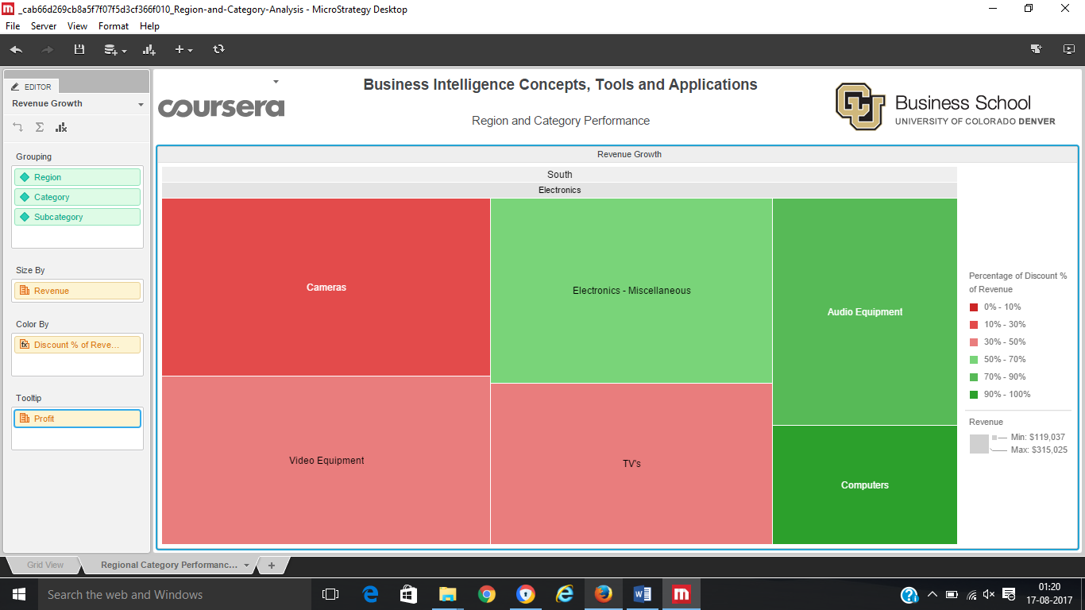

Ans: The camera sub-category in South region is problematic, when color by Discount %of Revenue.